# Lab – 0 Python Installation

Tasks:

## Python IDLE installation

1. Download and Install the latest version of Python. Click “**Windows**” (or other operating systems if required) instead of clicking “Download Python 3.x.x” directly.

<https://www.python.org/downloads/>

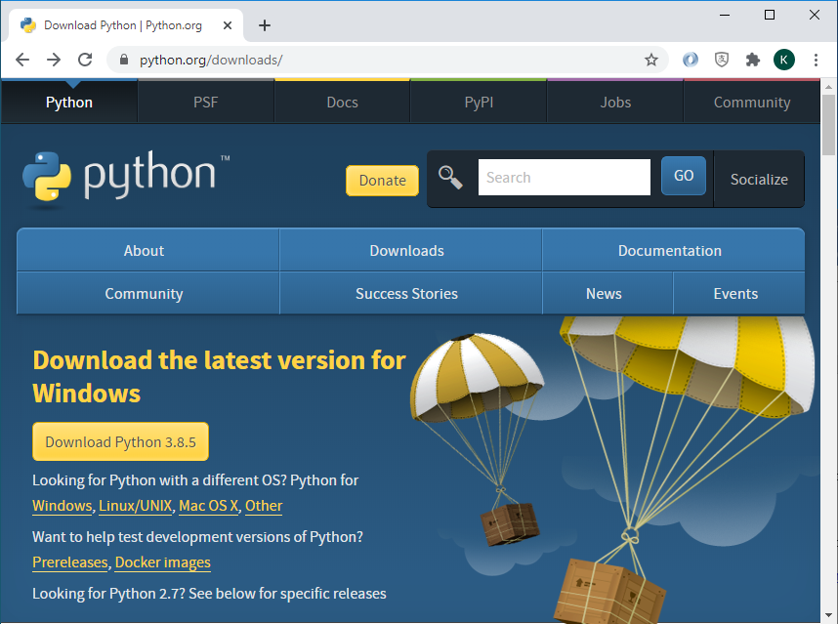

1.

1. Download “**Windows x86 64-bit executable installer**” (more preferred) for 64-bit windows or “Windows x86 executable installer” for 32-bit windows .

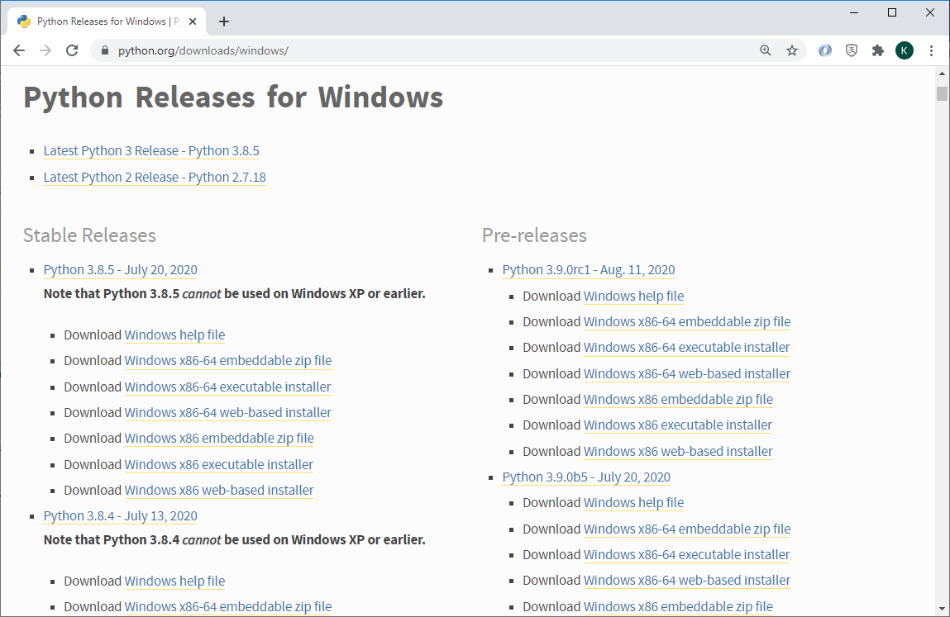

1. Remember to tick “**Add Python 3.x to PATH**” checkbox and click “**Customize installation**”

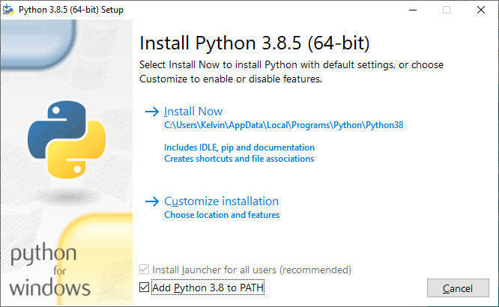

1.

2.

1. Just click “**Next**” in this page

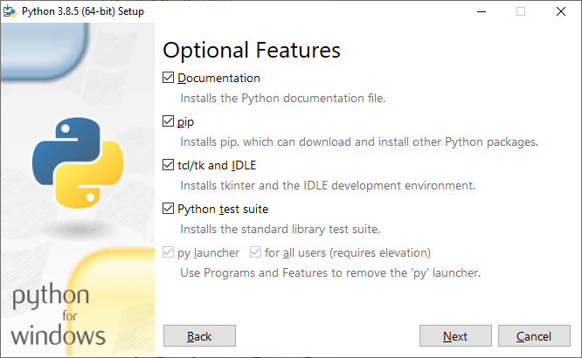

1.

1. Click “**Install for all users**”. The Customize install location will be change to C:\Program Files\Python3x automatically. Change the location to **C:\Python3x** instead of locating Python inside the Program Files Folder since Django in Windows do not support long path name and path name with spaces. Click “**Install**” and follow the rest of steps to finish the Python installation.

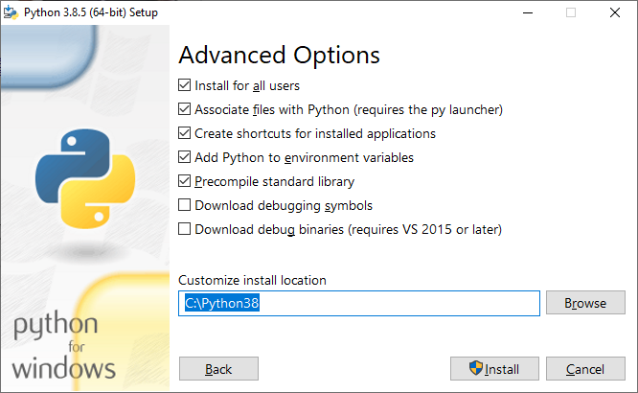

3.

1.

2.

1. Before closing this dialogue, remember to “**Disable path length limit**” by clicking it. Click “**Close**” afterwards.

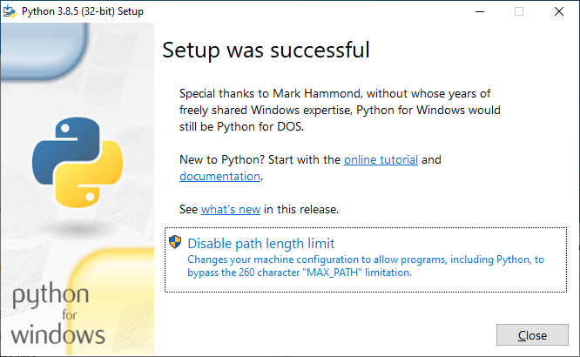

1.

2.

1. You may have to uninstall the Python and reinstall it if you have missed any of the above steps.

Tasks:

1. Create a folder called “Lab0” on your desktop.
2. Open the **Python** Shell
3. Create a new python program and enter the following code segment.

import sys

print (sys.path)

1. Save this program by File 🡪 Save or (Ctrl + S). Locate the folder on **Desktop\Lab0** and enter **lab00_q4** in the File name field (file extension .py is optional)
2. Run this program by Run 🡪 Run Module or F5. Paste the output below

## Visual Studio Code Installation

1. Download and Install the latest version of Visual Studio Code from the download page. Click “Other downloads” and do not download the Stable version directly.

<https://code.visualstudio.com/>

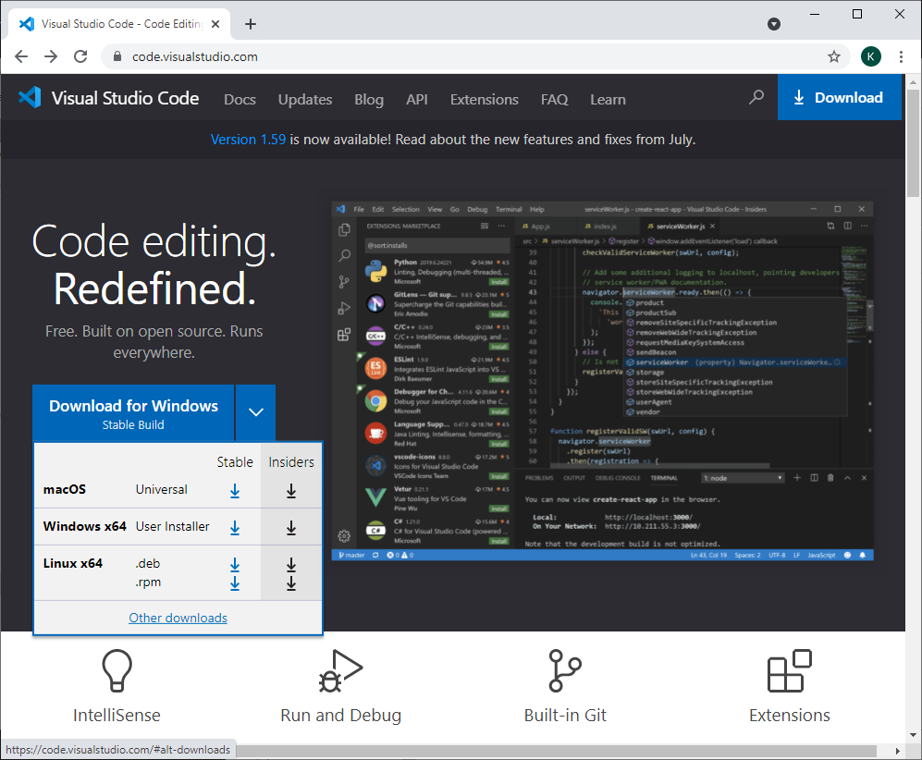

1.

1. Download “**System Installer**” and “**64 bit**” version of Visual Studio Code.

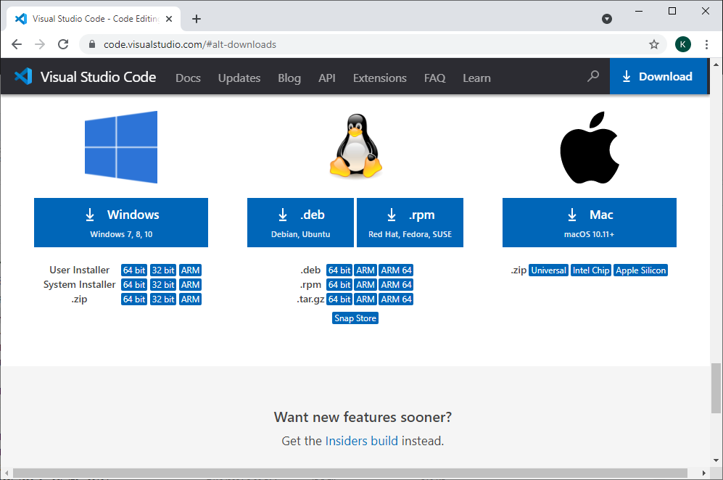

1.

1. Click the “**I accept the agreement**” radio button and then click on the “**Next >**” button to continue.

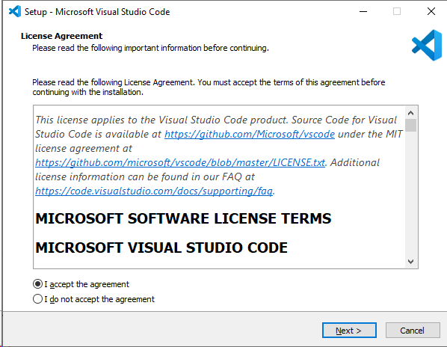

1.

2.

1. Pay attention that the folder should be under **Program Files** instead of **Users**. Click on the “**Next >**” button to continue.

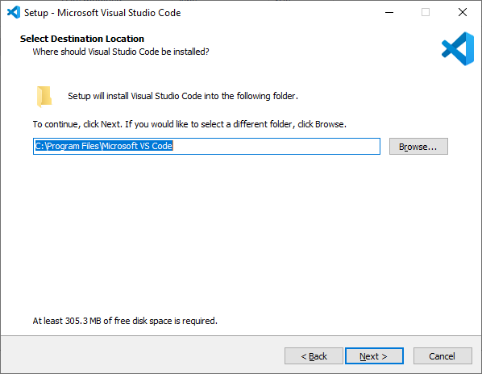

2.

1.

1. Click on the “**Next >**” button to continue.

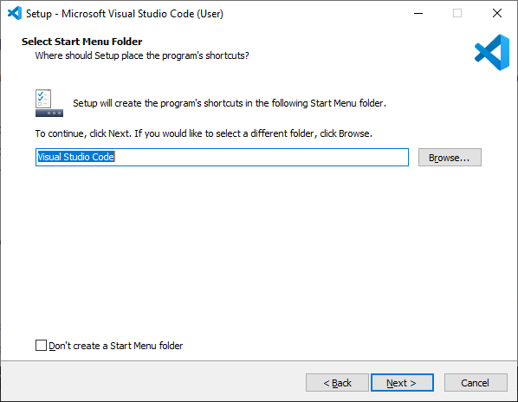

1.

1. Check the **two boxes** as shown below and click on the “**Next >**” button to continue.

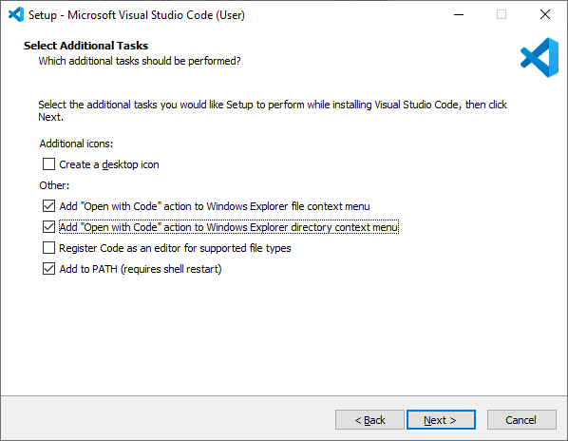

2.

1.

1. Click on the “**Install**” button to continue.

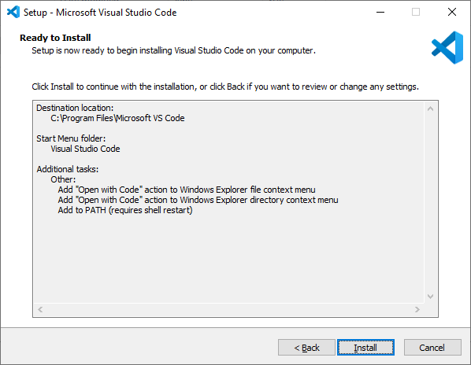

1.

1. Click on the “**Finish**” button to complete the Visual Studio Code Setup. Do not launch Visual Studio Code at this moment.

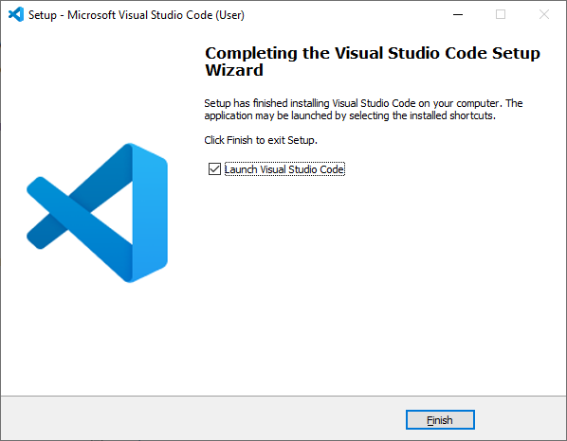

1.

2.

1. Click on the Extensions icon in the **Activity Bar** on the side of VS Code or the **View: Extensions** command (Ctrl+Shift+X).

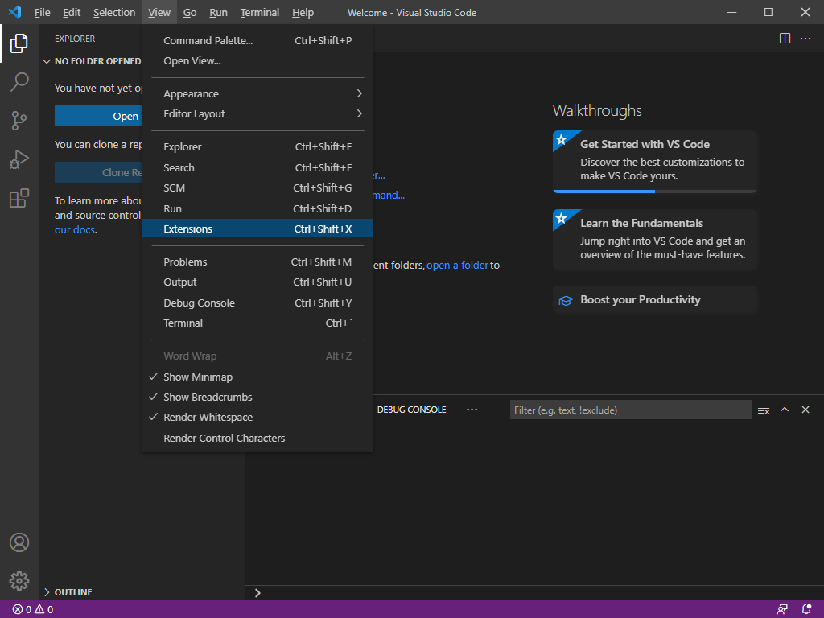

1.

2.

1. Type **Python** to install the Python extension for VS Code from the Visual Studio Marketplace. The Python extension is named Python and it’s published by **Microsoft**. Click the “**Install**” button to continue.

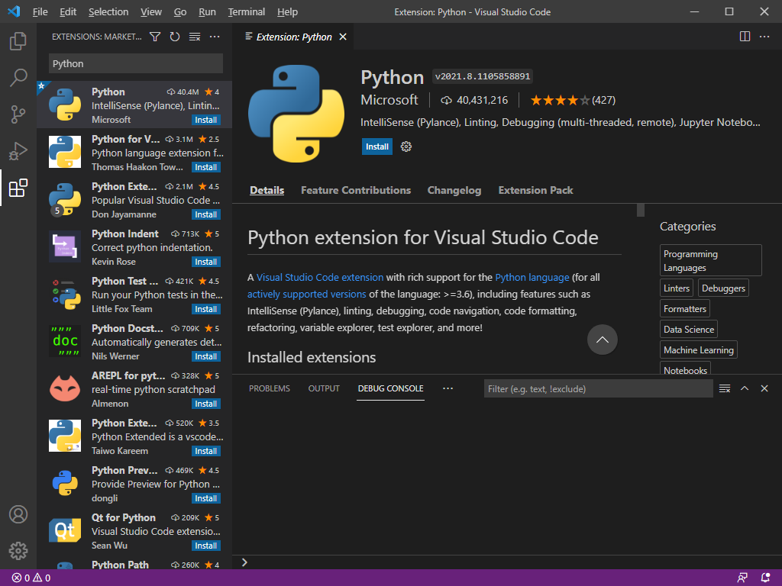

1.

2.

3.

System Check:

1. Create a Folder called “Hello” inside the Documents Folder.

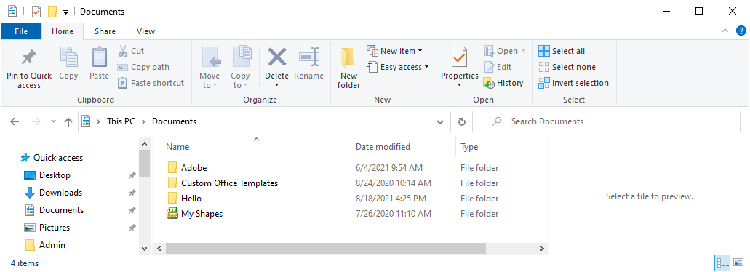

1.

2.

1. Right click on the “**Hello**” Folder, Click “**Open with Code**”

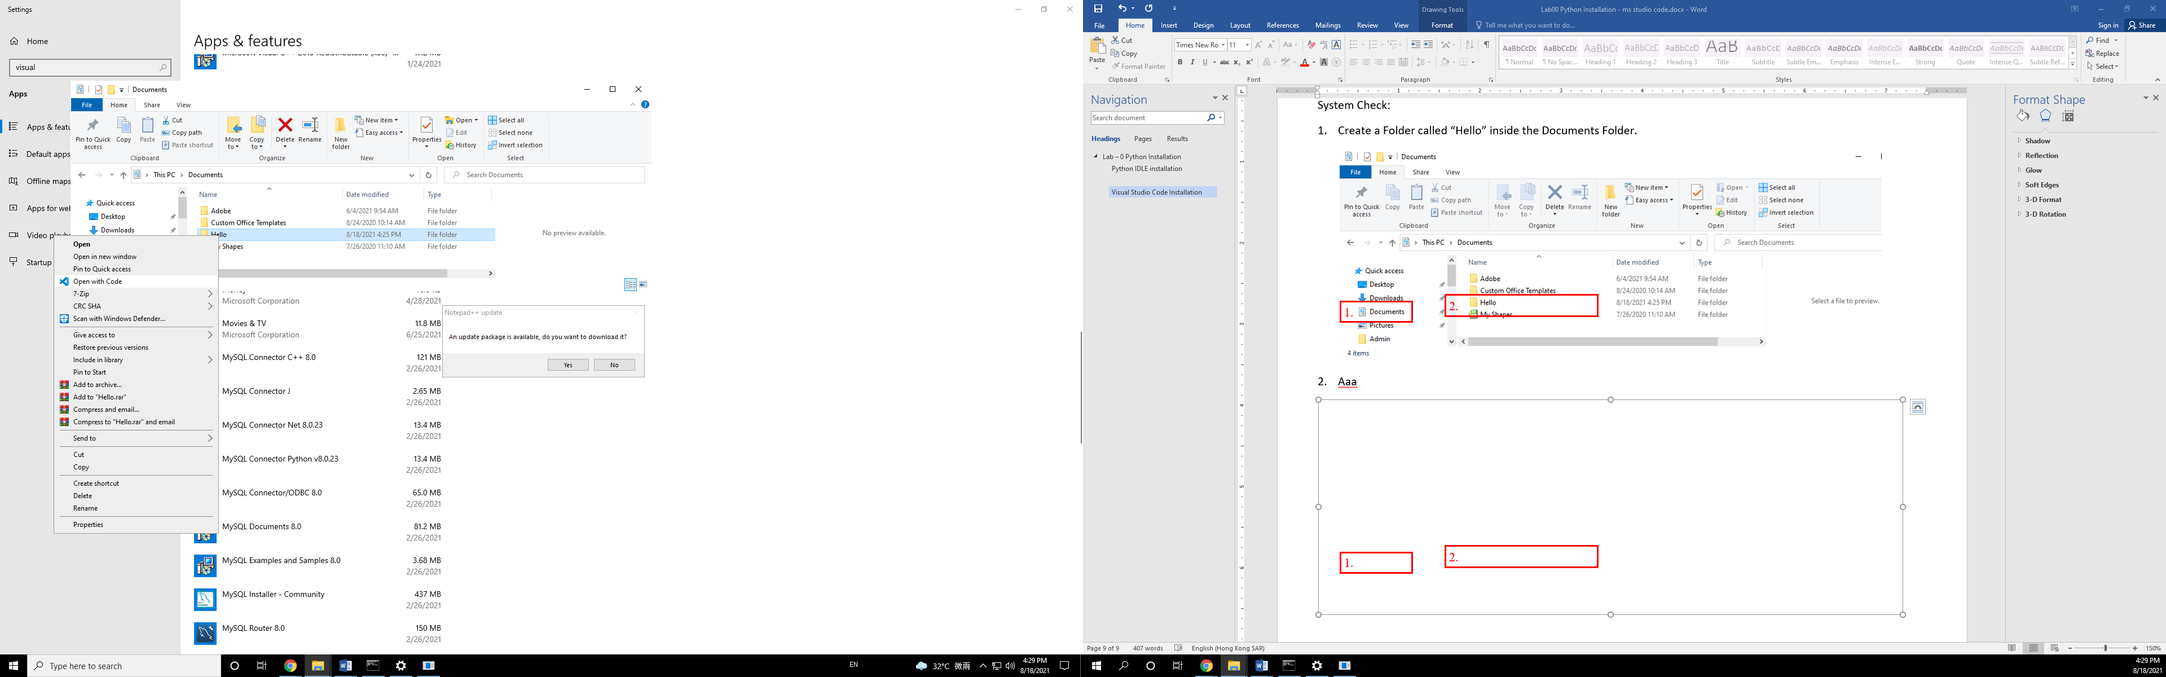

1.

2.

1. Normally, you should trust the author of the files in this folder. Just click “**Yes, I trust the authors**” and this would enable all features for VS code and Python (e.g. reading / writing files using Python)

